**TOPIC: Analysing the impact of weather on EPL match outcomes**

**DATA SOURCE:**

https://www.football-data.co.uk/englandm.php

The English Premier League match data, including daily updates on gambling odds, is available in CSV format. This dataset provides detailed match information, such as match times, participating teams, goals, shots on target, and fouls committed.

https://www.premierleague.com/home

The league table, featuring daily updates on total games played, team standings, wins, and losses, is available on the official Premier League website under Premier League Tables. Leagues tables with goal scores, loss information will be web scrapped.

https://meteostat.net/en/

Meteostat offers open access to weather and climate data, sourcing information from national weather services like NOAA and DWD. Hourly weather records include details such as temperature, wind speed, relative humidity, and overall weather conditions. The data was retrieved via API calls and exported in Excel format.

**INTERESTING CHARACTERISTICS:**

This project focuses on exploring how weather conditions impact the outcomes of English Premier League (EPL) matches. By integrating detailed match statistics, hourly weather data, and betting odds from gambling companies, this analysis aims to uncover correlations between factors like temperature, precipitation, wind speed, and team performance. These insights could potentially reveal patterns that influence match outcomes, offering valuable predictions for betting strategies. With comprehensive data covering multiple perspectives, this dataset is well-suited for both predictive modelling and deeper statistical analysis and will be beneficial for those who gamble on matches.

**SRUCTURE OF DATA SETS:**

The dataset spans five seasons of the English Premier League, from 2019 to 2023, featuring 26 teams from 18 different cities. Hourly weather data is collected from the nearest weather station to each match location. The key attributes include:

Club: Str, names of the club (e.g., Manchester United)

Date: Datetime, date and time of the match kickoff (e.g., 2020-02-03 20:00)

Goals: Int, number of goals scored

FullTimeResult: Str, 'H' representing a home team win and 'A' for an away team win

AwayTeamYellowCards: Int, number of yellow cards received by the away team

HomeTeamOdds: Float, betting odds for the home team, provided by gambling companies

WeatherConditionCode: Int, numeric code representing the weather conditions during the match

**PROPOSED KPI:**

1. Win/Loss ratio of teams in different weather conditions (e.g., rain, snow, high wind).
2. Correlation between the number of shots taken and weather conditions.
3. Average goals per match in varying weather conditions.
4. Average fouls committed and cards received under varying weather conditions.
5. Average betting odds for home versus away teams in adverse weather conditions.

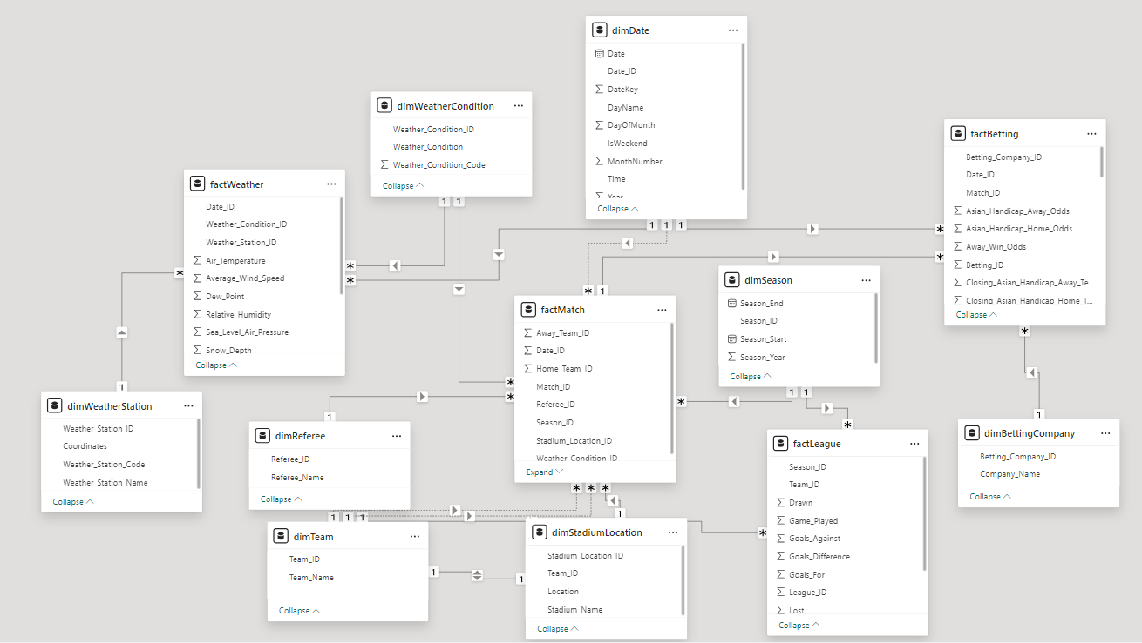

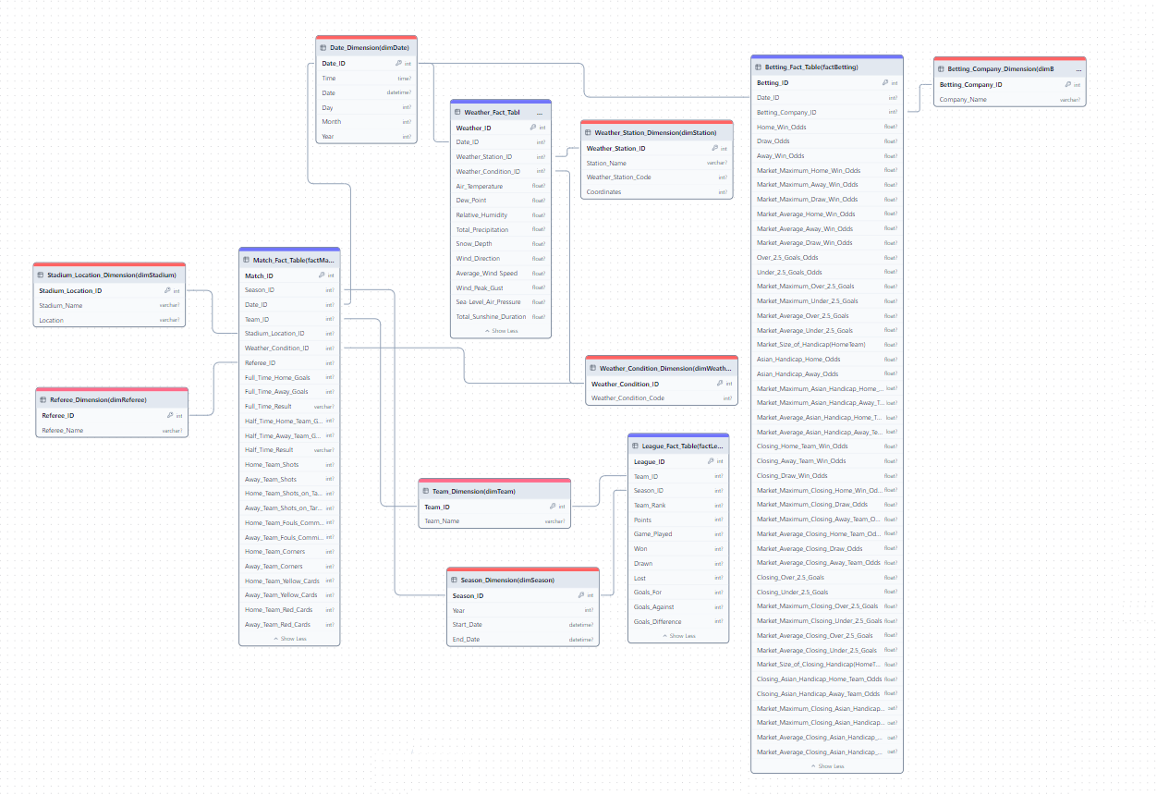

|  |  |  |
| --- | --- | --- |
| **Tables** | | |
| **Dimensions** | **Facts** | **StagingTable** |
| dbo.dimBettingCompany | dbo.factBetting | dbo.Staging_DateInfo |
| dbo.dimDate | dbo.factLeague |  |
| dbo.dimReferee | dbo.factMatch |  |
| dbo.dimSeason | dbo.factWeather |  |
| dbo.dimStadiumLocation |  |  |
| dbo.dimTeam |  |  |
| dbo.dimWeatherCondition |  |  |
| dbo.dimWeatherStation |  |  |

**ETL Process of dimBettingCompany, dimTeam, dimWeatherCondition**

1. A screenshot of a computer program

   Description automatically generatedExtract the source data
2. Convert the data type
3. Lookup for new data
4. Check for null values
5. Slowly Changing Dimension for changes
6. A computer screen shot of a diagram

   Description automatically generatedA screenshot of a computer

   Description automatically generatedLoad

**ETL Process of dimStadiumLocation, dimWeatherStation**

1. Extract the source data
2. Convert the data type
3. Lookup for new data
4. Slowly Changing Dimension to update possible name (Stadium name, Weather Station name) changes
5. Load

**ETL Process of dimReferee**

1. Foreach Loop Container to loop through 5 csv files
2. Extract the source
3. Sort to remove duplicates
4. Lookup for new data
5. Slowly Changing Dimension for updates
6. Load

**ETL Process of dimSeason**

1. Foreach Loop Container to loop through 5 csv files
2. Extract the source
3. Derive a column ‘DateValue’, database date (DT_DBDATE)
4. Sort to remove duplicates
5. Check for null values
6. Load it to the Staging Table
7. SQL Command to read the first record and last record of the Staging Table and update it to dimSeason
   1. 09/08/2019 -> Start Date
   2. 26/07/2020 -> End Date
   3. 2019 -> Season Year
8. Truncate the Staging Table

**ETL Process of factLeague**

1. Extract the source
2. Convert the data type
3. Lookup for Team_ID, Season_ID
4. Lookup for new data
5. Load

**ETL Process of factWeather**

1. Foreach Loop Container for 13 csv files
2. Separate Date and Time
3. Lookup for Date_ID
4. Covert null values to -9999
5. Lookup for Weather_Condition_ID and Weather_Station_ID
6. Lookup for new data
7. Load

**ETL Process of factMatch**

1. Foreach Loop Container for 5 csv files
2. Derive columns Year, Date, Time
3. Roundup minutes to the nearest hour (17:05 -> 17:00)
4. Convert Team names (Man U -> Manchester United)
5. Lookup for Home_Team_ID and Away_Team_ID
6. Lookup for the Date_ID which matches with factWeather to get Weather_ID
7. Lookup for new data
8. Load

**ETL Process of factBetting**

**

1. Same as factMatch
2. Unpivot the betting columns to store Odds value
3. Split betting types like "Market", "Closing “, "Home“ and handle empty company values as ‘unknown’
4. Trim the names
5. Convert the values as convert null odd values as 0
6. Lookup tables for relevant IDs
7. Aggregate to Group by for IDs and Maximum to avoid multiple entries for the same match
8. Load

**Data Visualization in PowerBI (League)**

1. Season selection
2. Match related parameter
   1. Average Goals per Match
   2. Total Red Cards
   3. Total Fouls
   4. Total Goals
   5. Total Shots on Target
3. Weather Condition parameter
   1. Clear
   2. Cloudy
   3. Fair
   4. etc

**Data Visualization in PowerBI (Team)**

1. A screenshot of a graph

   Description automatically generatedSeason selection
2. Match related parameter
   1. Average Goals per Match
   2. Total Red Cards
   3. Total Fouls
   4. Total Goals
   5. Total Shots on Target
   6. etc
3. Weather parameter
   1. Average temperature
   2. Snow Depth
   3. Wind Speed
   4. Total Precipitation
   5. etc

**Data Visualization in PowerBI (Betting)**

1. A graph on a screen

   Description automatically generatedSeason selection
2. Betting Type Selection
   1. Away Win Odds
   2. Home Win Odds
   3. Draw Win Odds
   4. Over 2.5 Goals Odds
   5. Under 2.5 Goals Odds
3. Weather Condition parameter
   1. Clear
   2. Cloudy
   3. Fair
   4. Etc
4. Weather Parameter
   1. Average temperature
   2. Total Precipitation
   3. Win Speed
   4. Etc

**Data Visualization in PowerBI (Comparison)**

1. Season selection
2. Team selection
   1. Relative Winning Percentages
   2. Total Winning Percentages
   3. Relative Match Scores
      1. Goals
      2. Shots
      3. Fouls
      4. Red Cards
3. Relative Win, Loss, Draw by Weather Condition

**Result**

1. **Manchester Cit**y has maintained a winning percentage of 73% over the past five years. However, **Arsenal** has played under **various weather conditions** and tends to perform well across different weather conditions.
2. **West Ham United** took the greatest number of shots on target when it was **cloudy**, with 390 shots.
3. **Tottenham Hotspur** has the highest average goals per match, with 6.50, when it **rains**.
4. **Brighton & Hove Albion** tends to commit more fouls than other teams, with 1,998 fouls, but its winning percentage is only 32%.
5. Higher odds for the away team indicate a stronger belief in the home team's likelihood of winning. However, **the market’s Maximum Odds** for a **Home Win** are **higher** during **snowy conditions.**

**Difficulties Encountered**

1. Weather Data Collection
   * 1. Many sources require paid API access.
     2. Data for certain locations or dates may be unavailable.
2. Data Conversion Challenges
   * 1. Date Conversion: Ensuring alignment between match times and weather data.
     2. Granularity Issues: Weather data is recorded at different intervals, while match data varies in terms of timing and measurement units. Proper conversion is essential to maintain consistency.
3. Understanding of Football and Weather Data Establishing proper relationships between football match data and weather conditions requires a solid understanding of both domains to ensure accurate analysis.
4. Further Analysis
   1. Needs additional match data, including player information, more referee information would provide deeper insights.
   2. Statistical modelling of weather and its impact on football performance remains a potential area for further exploration.

**Weather_Fact_Table(factWeather)**

|  |  |  |  |  |  |
| --- | --- | --- | --- | --- | --- |
| Key | Name | Data Type | Null | Attributes | Description |
| 1.PK | **Weather_ID** (Primary Key) | INT |  | IDENTITY | Primary Key for **factWeather** |
| 2.FK | **Date_ID** | INT |  |  | Foreign Key for dimDate |
| 3.FK | **Weather_Station_ID** | INT |  |  | Foreign Key for dimWeather Station |
| 4.FK | **Weather_Condition_ID** (Foriegn Key) | INT |  |  | Foreign Key for dimWeatherCondition |
| 5 | **Air_Temperature** | FLOAT |  |  | Air Temperature (°C) |
| 6 | **Dew_Point** | FLOAT |  |  | Dew Point (°C) |
| 7 | **Relative_Humidity** | FLOAT |  |  | Relative Humidity (%) |
| 8 | **Total_Precipitation** | FLOAT |  |  | Total Precipitation (mm) |
| 9 | **Snow_Depth** | FLOAT |  |  | Snow Depth (mm) |
| 10 | **Wind_Direction** | FLOAT |  |  | Wind (from) Direction |
| 11 | **Average_Wind_Speed** | FLOAT |  |  | Average Wind Speed (km/h) |
| 12 | **Wind_Peak_Gust** | FLOAT |  |  | Wind Peak Gust (km/h) |
| 13 | **Sea-Level_Air_Pressure** | FLOAT |  |  | Sea-Level Air Pressure (hpa) |
| 14 | **Total_Sunshine_Duration** | FLOAT |  |  | Total Sunshine Duration (minutes) |

**League_Fact_Table(factLeague)**

|  |  |  |  |  |  |
| --- | --- | --- | --- | --- | --- |
| Key | Name | Data Type | Null | Attributes | Description |
| 1.PK | **League_ID** (Primary Key) | INT |  | IDENTITY | Primary Key for **factFact** |
| 2.FK | **Team_ID** | INT |  |  | Foreign Key for dimTeam |
| 3.FK | **Season_ID** | INT |  |  | Foreign Key for dimSeason |
| 4 | **Team_Rank** | INT |  |  | Final team rank of the season |
| 5 | **Points** | INT |  |  | Total points earned (Win = 3, Draw = 1, Lost = 0) |
| 6 | **Game_Played** | INT |  |  | The total number of games played |
| 7 | **Won** | INT |  |  | The total number of games won |
| 8 | **Drawn** | INT |  |  | The total number of games drawn |
| 9 | **Lost** | INT |  |  | The total number of games lost |
| 10 | **Goals_For** | INT |  |  | The number of goals achieved |
| 11 | **Goals_Against** | INT |  |  | The number of goals lost |
| 12 | **Goals_Difference** | INT |  |  | Goals For – Goals Against |

**Match_Fact_Table(factMatch)**

|  |  |  |  |  |  |
| --- | --- | --- | --- | --- | --- |
| Key | Name | Data Type | Null | Attributes | Description |
| 1.PK | **Match_ID** (Primary Key) | INT |  | IDENTITY | Primary Key for **factMatch** |
| 2.FK | **Season_ID** (Foreign Key) | INT |  |  | Foreign Key for dimSeason |
| 3 .FK | **Date_ID** (Foreign Key) | INT |  |  | Foreign Key for dimDate |
| 4.FK | **Home_Team_ID** (Foreign Key) | INT |  |  | Foreign Key for dimTeam |
| 5 FK | **Away_Team_ID** | INT |  |  | Foreign Key for dimTeam |
| 6 .FK | **Stadium_Location_ID** (Foreign Key) | INT |  |  | Foreign Key for dimStadiumLocation |
| 7 .FK | **Weather_Condition_ID** (Foreign Key) | INT |  |  | Foreign Key for dimWeatherCondition |
| 8 .FK | **Referee_ID** | INT |  |  | Foreign Key for dimReferee |
| 9 | **Full_Time_Home_Goals** | INT |  |  | The number of goals scored by Home Team at full time |
| 10 | **Full_Time_Away_Goals** | INT |  |  | The number of goals scored by Away Team at full time |
| 11 | **Full_Time_Result** | VARCHAR(20) |  |  | Full Time Result (H = Home Win, D = Draw, A = Away Win) |
| 12 | **Half_Time_Home_Team_Goals** | INT |  |  | The number of goals scored by Home Team at half time |
| 13 | **Half_Time_Away_Team_Goals** | INT |  |  | The number of goals scored by Away Team at half time |
| 14 | **Half_Time_Result** | VARCHAR(20) |  |  | Half Time Result (H = Home Win, D = Draw, A = Away Win) |
| 15 | **Home_Team_Shots** | INT |  |  | Shots made by Home Team |
| 16 | **Away_Team_Shots** | INT |  |  | Shot made by Away Team |
| 17 | **Home_Team_Shots_on_Target** | INT |  |  | Shots on target made by Home Team |
| 18 | **Away_Team_Shots_on_Target** | INT |  |  | Shots on target made by Away Team |
| 19 | **Home_Team_Fouls_Committed** | INT |  |  | The number of fouls committed by Home Team |
| 20 | **Away_Team_Fouls_Committed** | INT |  |  | The number of fouls committed by Away Team |
| 21 | **Home_Team_Corners** | INT |  |  | The number of corners by Home Team |
| 22 | **Away_Team_Corners** | INT |  |  | The number of corners by Away Team |
| 23 | **Home_Team_Yellow_Cards** | INT |  |  | The number of yellow cards given to Home Team |
| 24 | **Away_Team_Yellow_Cards** | INT |  |  | The number of yellow cards given to Away Team |
| 25 | **Home_Team Red_Cards** | INT |  |  | The number of red cards given to Home Team |
| 26 | **Away_Team_Red_Cards** | INT |  |  | The number of red cards given to Away Team |

**Betting_Fact_Table (factBetting)**

|  |  |  |  |  |  |
| --- | --- | --- | --- | --- | --- |
| Key | Name | Data Type | Null | Attributes | Description |
| 1.PK | **Betting_ID** (Primary Key) | INT |  | IDENTITY | Primary Key for **factBetting** |
| 2. | **Match_ID** | INT |  |  |  |
| 3.FK | **Date_ID** (Foreign Key) | INT |  |  | Foreign key for dimDate |
| 4.FK | **Betting_Company_ID** (Foreign Key) | INT |  |  | Foreign key for dimBettingCompany |
| 5 | **Home_Win_Odds** | FLOAT |  |  | The odds of home team winning |
| 6 | **Draw_Odds** | FLOAT |  |  | The odds of match ending in draw |
| 7 | **Away_Win_Odds** | FLOAT |  |  | The odds of away team winning |
| 8 | **Market_Maximum_Home_Win_Odds** | FLOAT |  |  | Highest home win odds offered by any bookmaker |
| 9 | **Market_Maximum_Away_Win_Odds** | FLOAT |  |  | Highest away win odds offered by any bookmaker |
| 10 | **Market_Maximum_Draw_Win_Odds** | FLOAT |  |  | Highest draw odds offered by any bookmaker |
| 11 | **Market_Average_Home_Win_Odds** | FLOAT |  |  | Average odds of all bookmakers’ home wind odds |
| 12 | **Market_Average_Away_Win_Odds** | FLOAT |  |  | Average odds of all bookmakers’ away win odds |
| 13 | **Market_Average_Draw_Win_Odds** | FLOAT |  |  | Average odds of all bookmakers’ draw odds |
| 14 | **Over_2_5_Goals_Odds** | FLOAT |  |  | Odds for total match goals exceeding 2.5 |
| 15 | **Under_2_5 Goals_Odds** | FLOAT |  |  | Odds for total match goals being 2.5 or fewer |
| 16 | **Market_Maximum_Over_2.5_Goals** | FLOAT |  |  | Highest odds for over 2.5 goals from any bookmaker |
| 17 | **Market_Maximum_Under_2_5_Goals** | FLOAT |  |  | Highest odds for under 2.5 goals from any bookmaker |
| 18 | **Market_Average_Over_2_5_Goals** | FLOAT |  |  | Average odds for over 2.5 goals across bookmakers |
| 19 | **Market_Average_Under_2_5_Goals** | FLOAT |  |  | Average odds for under 2.5 goals across bookmakers |
| 20 | **Market_Size_of_Handicap_Home_Team** | FLOAT |  |  | Betting **spread** of the handicap applied to the home team in a match (a negative value (e.g., **-1.5**) indicates that the home team is expected to perform better, a positive or zero value (e.g., **+0.5** or **0**) means the home team is less favoured, a bet on the home team wins only if they win by **at least 2 goals**.) |
| 21 | **Asian_Handicap_Home_Odds** | FLOAT |  |  | Odds adjusted for home team with an Asian Handicap |
| 22 | **Asian_Handicap_Away_Odds** | FLOAT |  |  | Odds adjusted for away team with an Asian Handicap |
| 23 | **Market_Maximum_Asian_Handicap_Home_Odds** | FLOAT |  |  | Highest Asian Handicap Odds for the home team |
| 24 | **Market_Maximum_Asian_Handicap_Away_Odds** | FLOAT |  |  | Highest Asian Handicap odds for the away team |
| 25 | **Market_Average_Asian_Handicap_Home_Odds** | FLOAT |  |  | Average Asian Handicap odds for the home team |
| 26 | **Market_Average_Asian_Handicap_Away_Odds** | FLOAT |  |  | Average Asian Handicap odds for the away team |
| 27 | **Closing_Home_Team_Win_Odds** | FLOAT |  |  | The final odds for the home team to win a match before the match starts |
| 28 | **Closing_Away_Team_Win_Odds** | FLOAT |  |  | The final odds for the away team to win before the match starts |
| 29 | **Closing_Draw_Win_Odds** | FLOAT |  |  | The final odds for a draw before the match starts |
| 30 | **Market_Maximum_Closing_Home_Win_Odds** | FLOAT |  |  | The highest home win odds at closing time |
| 31 | **Market_Maximum_Closing_Draw_Odds** | FLOAT |  |  | The highest draw odds at closing time |
| 32 | **Market_Maximum_Closing_Away_Team_Odds** | FLOAT |  |  | The highest away win odds at closing time |
| 33 | **Market_Average_Closing_Home_Team_Odds** | FLOAT |  |  | Average home win odds at closing time |
| 34 | **Market_Average_Closing_Draw_Odds** | FLOAT |  |  | Average draw odds at closing time |
| 35 | **Market_Average_Closing_Away_Team_Odds** | FLOAT |  |  | Average away odds at closing time |
| 36 | **Closing_Over_2_5_Goals** | FLOAT |  |  | Final odds for over 2.5 goals before the match starts |
| 37 | **Closing_Under_2_5_Goals** | FLOAT |  |  | Final odds for under 2.5 goals before the match starts |
| 38 | **Market_Maximum_Closing_Over_2_5_Goals** | FLOAT |  |  | Highest odds for over 2.5 goals at closing time |
| 39 | **Market_Maximum_Closing_Under_2_5_Goals** | FLOAT |  |  | Highest odds for under 2.5 goals at closing time |
| 40 | **Market_Average_Closing_Over_2_5_Goals** | FLOAT |  |  | Average odds for over 2.5 goals at closing time |
| 41 | **Market_Average_Closing_Under_2_5_Goals** | FLOAT |  |  | Average odds for under 2.5 goals at closing time |
| 42 | **Market_Size_of_Closing_Handicap_Home_Team** | FLOAT |  |  | Betting spread of handicap applied to the home team at the closing time (a negative value (e.g., **-1.5**) indicates that the home team is expected to perform better, a positive or zero value (e.g., **+0.5** or **0**) means the home team is less favoured, a bet on the home team wins only if they win by **at least 2 goals**.) |
| 43 | **Closing_Asian_Handicap_Home_Team_Odds** | FLOAT |  |  | Final Asian Handicap odds for the home team before the match |
| 44 | **Closing_Asian_Handicap_Away_Team_Odds** | FLOAT |  |  | Final Asian Handicap odds for the away team before the match |
| 45 | **Market_Maximum_Closing_Asian_Handicap_Home_Team_Odds** | FLOAT |  |  | Highest closing Asian Handicap odds for the home team |
| 46 | **Market_Maximum_Closing_Asian_Handicap_Away_Team_Odds** | FLOAT |  |  | Highest closing Asian Handicap odds for the away team |
| 47 | **Market_Average_Closing_Asian_Handicap_Home_Team_Odds** | FLOAT |  |  | Average closing Asian Handicap odds for the home team |
| 48 | **Market_Average_Closing_Asian_Handicap_Away_Team_Odds** | FLOAT |  |  | Average closing Asian Handicap odds for the away team |

**WeatherStationDimension(dimWeatherStation)**

|  |  |  |  |  |  |
| --- | --- | --- | --- | --- | --- |
| Key | Name | Data Type | Null | Attributes | Description |
| 1.PK | **Weather_Station_ID** (Primary Key) | INT |  | IDENTITY | Primary Key for **dimStation** |
| 2. | **Weather_Station_Name** | VARCHAR(100) |  |  | Name of the weather station e.g. London Weather Centre |
| 3. | **Weather_Station_Code** | INT |  |  | Weather Station Code “e.g. 03779” |
| 4. | **Coordinates** | INT |  |  | Map Coordinates e.g. 51.5085, -0.1257 |

**Weather_Condition_Dimension(dimWeatherCondition)**

|  |  |  |  |  |  |
| --- | --- | --- | --- | --- | --- |
| Key | Name | Data Type | Null | Attributes | Description |
| 1.PK | **Weather_Condition_ID** (Primary Key) | INT |  | IDENTITY | Primary Key for **dimWeatherCondition** |
| 2. | **Weather_Condition** | CHAR |  |  | Weather Condition e.g. Clear, Rain, Cloudy, etc. |
| 3. | **Weather_Condition_Code** | INT |  |  | Weather Condition Code e.g. 8 for Rain, 9 for Heavy Rain |

**Team_Dimension(dimTeam)**

|  |  |  |  |  |  |
| --- | --- | --- | --- | --- | --- |
| Key | Name | Data Type | Null | Attributes | Description |
| 1.PK | **Team_ID** (Primary Key) | INT |  | IDENTITY | Primary Key for **dimTeam** |
| 2. | **Team_Name** | VARCHAR(50) |  |  | Team Name e.g. Liverpool |

**Season_Dimension(dimSeason)**

|  |  |  |  |  |  |
| --- | --- | --- | --- | --- | --- |
| Key | Name | Data Type | Null | Attributes | Description |
| 1.PK | **Season_ID** (Primary Key) | INT |  | IDENTITY | Primary Key for **dimSeason** |
| 2. | **Season_Year** | INT |  |  | Year of the EPL Season e.g. 2019, 2020 |
| 3. | **Season_Start** | DATE |  |  | Start Date of Season |
| 4. | **Season_End** | DATE |  |  | End Date of Season |

**Date_Dimension(dimDate)**

|  |  |  |  |  |  |
| --- | --- | --- | --- | --- | --- |
| Key | Name | Data Type | Null | Attributes | Description |
| 1.PK | **Date_ID** (Primary Key) | INT |  | IDENTITY | Primary Key for **dimDate** |
| 2. | **Time** | TIME |  |  | Time (0 = AM 12:00 / 16 = PM 04:00) |
| 3. | **Date** | DATETIME |  |  | YYYY-MM-DD(‘2018-08-23’) |
| 4. | **DayName** | INT |  |  | Day in number.(‘28’) |
| 5. | **MonthNumber** | INT |  |  | Month in number. (‘02’) |
| 6. | **Year** | INT |  |  | Year.(‘ 2018’) |
| 7. | **DateKey** | INT |  |  | Datekey (20190101) |
| 8 | **DayofMonth** | INT |  |  | Day of the month |
| 9 | **IsWeekend** | BIT |  |  | Describes whether the match was played on a weekend or no |

**Betting_Company_Dimension(dimBettingCompany)**

|  |  |  |  |  |  |
| --- | --- | --- | --- | --- | --- |
| Key | Name | Data Type | Null | Attributes | Description |
| 1.PK | **Betting_Company_ID** (Primary Key) | INT |  | IDENTITY | Betting_Company_ID Primary Key for d**imBettingCompany** |
| 2. | **Company_Name** | VARCHAR(50) |  |  | Betting company Name e.g. Bet365, VCBet, etc. |

**Staging_Table(dbo.Stagingdateinfo)**

|  |  |  |  |  |  |
| --- | --- | --- | --- | --- | --- |
|  | **Name** | **Data Type** | **Null** | **Attributes** | **Description** |
| **1** | DateValue | Date |  |  |  |

**Referee_Dimension(dimReferee)**

|  |  |  |  |  |  |
| --- | --- | --- | --- | --- | --- |
| Key | Name | Data Type | Null | Attributes | Description |
| 1.PK | **Referee_ID** (Primary Key) | INT |  | IDENTITY | Primary Key for dimReferee |
| 2. | **Referee_Name** | VARCHAR(50) |  |  | Referee Name e.g. M Oliver |

**Stadium_Location_Dimension(dimStadiumLocation)**

|  |  |  |  |  |  |
| --- | --- | --- | --- | --- | --- |
| Key | Name | Data Type | Null | Attributes | Description |
| 1.PK | **Stadium_Location_ID** (Primary Key) | INT |  | IDENTITY | Primary Key for dimStadium |
| 2. | **Stadium _Name** | VARCHAR(50) |  |  | Stadium Name e.g. Emirates Stadium |
| 3. | **Location** | VARCHAR(20) |  |  | Location Name e.g. London |
| 4. | **Team_ID** | INT |  |  | ID of each respective Teams **Primary Key** for **dimTeam** |